  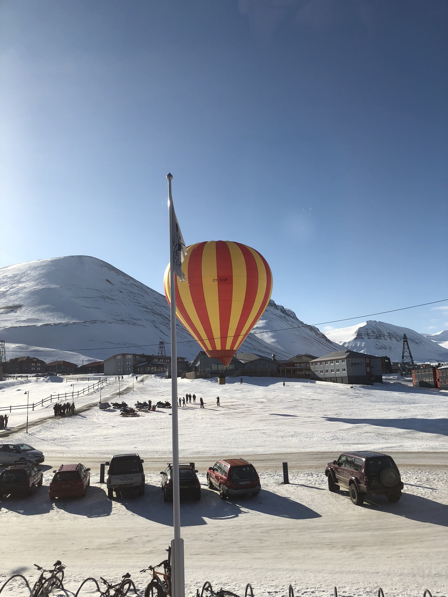 | Arctic Symposium & Workshop |     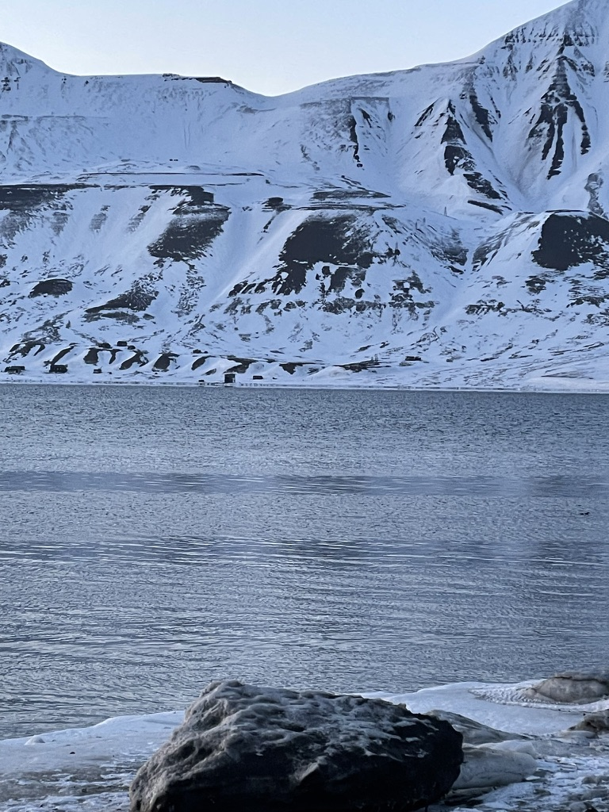
 | Arctic Organic Pollutants in a Changing Environment
 | Arctic Climate Change as a Driver of Pollutant Mobility
 | 2–4 November 2026; Funken Lodge, Longyearbyen, Svalbard, Norway
 | Organized by the Norwegian University of Life Sciences (NMBU) in collaboration with the UArctic Regional Centre in China and the International Joint Research Centre for Persistent and Toxic Substances (IJRC-PTS)
 | Please follow our website: www.persitox.com for details about program, flight arrival and departure suggestions and hotel reservation

Background & Scope
The Arctic is warming three to four times faster than the global average, fundamentally altering the transport, storage, remobilisation, and biological fate of organic contaminants. Legacy pollutants long stored in ice, snow, and permafrost are being released, while chemicals of emerging Arctic concern (CEACs) — including PFAS and pharmaceuticals — continue to reach the region through long-range transport and expanding local sources. This combined symposium and workshop brings together researchers, monitoring specialists, and early-career scientists to examine how climate change is reshaping pollutant mobility in the Arctic, and to discuss integrated approaches for monitoring and assessment. The aim of the meeting will be to provide input to a joint white paper and a comprehensive review on “Chemicals of emerging Arctic concern in a changing Environment – Global implications and consequences”.

Thematic Focus
- Long-range transport and local sources of Arctic organic pollutants
- Climate-driven remobilisation from ice, glaciers, snow, and permafrost
- Chemicals of Emerging Arctic Concern (CEACs): PFAS, pharmaceuticals/PPCPs, and beyond
- Bioaccumulation, food-web transfer, and effects on wildlife and human health
- Local pollution and sustainable solutions in Arctic settlements

Format
A compact, discussion-oriented meeting combining a symposium oral and poster presentations with a daily inter-active workshop session at the afternoon session to identify priorities and collaborative opportunities.

Accommodation (please note discounted price until 15. September)
Funken Lodge has reserved 30 rooms for conference participants until September 15, 2026, at a special conference rate of NOK 2,599 per night. Reservations can be made through the Hurtigruten Svalbard website website: Funken Lodge i Longyearbyen Hurtigruten Svalbard using the promo code NORULS2026 and the group name Norwegian University of Life Sciences. Other convenient hotel opportunities in Longyearbyen can be found at: Hotels in Longyearbyen and recommendations at our website of nearby accommodations at modest prices.

Who Should Attend
Environmental chemists, ecotoxicologists, Arctic monitoring specialists, PhD students and postdocs, and stakeholders engaged in Arctic pollution research and management.

Key Dates
First announcement / call for contributions | July 2026
Abstract submission deadline | 1st October 2026
Notification of acceptance | 15th October 2026
Regular registration deadline | 15th October 2026
Late registration | after 15 October 2026
Hotel Funken Reservation Discounted price | Before 15th September 2026
Symposium & workshop 2–4 November 2026 | Start 2. November (morning)  C losure 4. November before lunch (1200)
Symposium Arrival and departures recommendations (OSL-LYR and return) | Arrival Sunday 1st November morning flight OSL  Departure 5th November morning flight

Registration Fees
Regular registration (on or before 15 October 2026) | NOK 4 000
Late registration (after 15 October 2026) | NOK 5000
Student / PhD registration | NOK 2 000

The registration fee covers participation in the mini-symposium and workshop, the book of abstracts, Lunch and coffee breaks. Travel and overnight acommodation including breakfast are not included. For payment details see the registration portal: www.persitox.com/registration

Registration & Abstracts
Expressions of interest and abstract submissions (max. 250 words) should be sent to the abstract account at abstracts@persitox.com (this is an archiving account which forwards all abstract entries to Roland Kallenborn and Li Yifan (Dr_Li_Yifan@163.com).There will be a limited number of contributed presentation slots. To benefit from the regular fee of NOK 4 000, please register on or before 15 October 2026; registrations received after this date are subject to the late fee of NOK 5000. Registrations can also be done here

Practical Information
The meeting will be held at the Funken Lodge, Longyearbyen, Svalbard. The number of participants is initially restricted to max. 50 (incl. students). Therefore, please contact the organizers for confirmation before transferring the registration fee. Longyearbyen is served by daily flights from mainland Norway (via Oslo/Tromsø). Please follow the Persitox.com website on details for arrival and departure suggestions, program updates and other registration details.

Contact & Organising Committee
Prof. Dr. Roland Kallenborn (UArctic Chair) & Prof. Yifan Li (International Joint Research Center on Persistent toxic substances (IJRC-PTS)
Conference Secretariat: Norwegian University of Life Sciences (NMBU), Ås, Norway
E-mail: roland.kallenborn@nmbu.no
Please circulate widely among interested colleagues and networks.

